**Field Customizer Hands-on**

* Open Command prompt
* Navigate to your favourite folder
* Ex: C:\Jenkins\SPFx\Nodejs\SPFx\extension
* Create new folder for app customizer
* Ex: fieldcustomizerEx1
* Create spfx solution >yo @microsoft/sharepoint

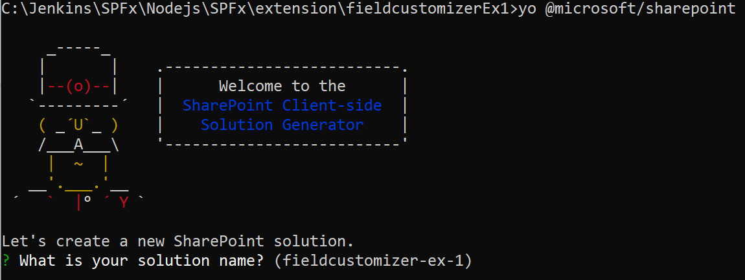

* Give Solution name
* Select “Extension”
* Then select Field customizer

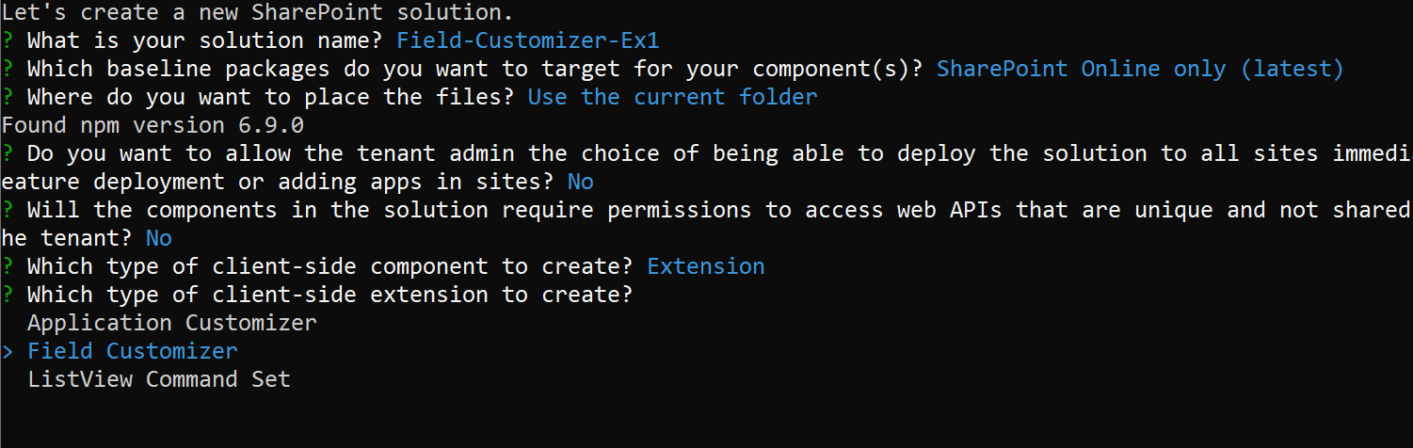

What is your solution name? Field-Customizer-Ex1

Which baseline packages do you want to target for your component(s)? SharePoint Online only (latest)

Where do you want to place the files? Use the current folder

Found npm version 6.9.0

Do you want to allow the tenant admin the choice of being able to deploy the solution to all sites immediately without running any f

eature deployment or adding apps in sites? No

Will the components in the solution require permissions to access web APIs that are unique and not shared with other components in t

he tenant? No

Which type of client-side component to create? Extension

Which type of client-side extension to create? Field Customizer

Add new Field Customizer to solution field-customizer-ex-1.

What is your Field Customizer name? MyFieldCustomizer

What is your Field Customizer description? MyFieldCustomizer description

Which framework would you like to use? No JavaScript framework

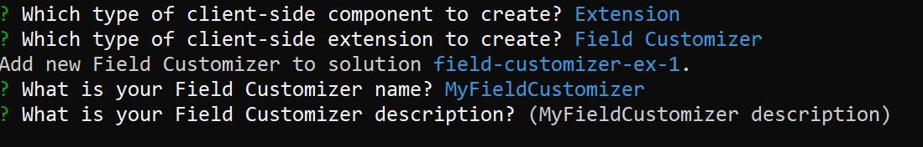

* At this point, Yeoman installs the required dependencies and scaffolds the solution files along with the **MyFieldCustomizer** extension.
* Type **code .** into the console to start Visual Studio Code.

Test the Field Customizer

Create a SharePoint List “ProductFeedback”



Add new column “Percentage”

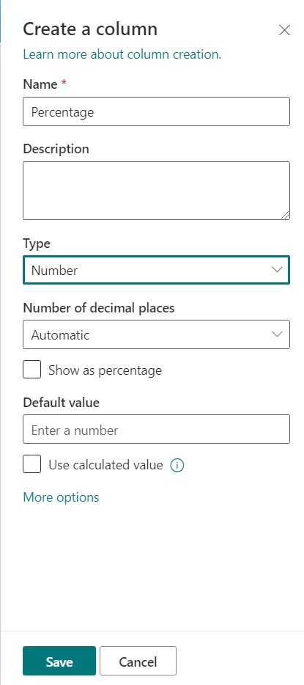

Add three records

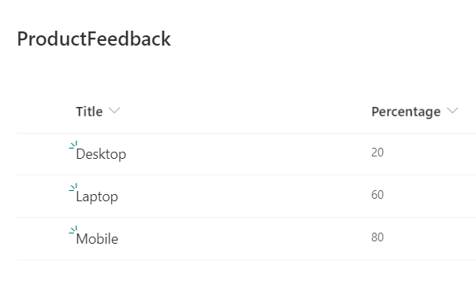

* Within Visual Studio Code, open the **./config/serve.json** file.

Update the Page url - update - created list url https://jpower4mvp.sharepoint.com/sites/SPFxTraining/Lists/Orders/AllItems.aspx

InternalFieldName - modify to created new field name Percentage

Then it looks like below

"default": {

            "pageUrl": "https://jpower4mvp.sharepoint.com/sites/SPFxTraining/Lists/Orders/AllItems.aspx",

            "fieldCustomizers": {

                "Percentage": {

                    "id": "1052338b-ed07-4316-9e1e-b28c81a83945",

                    "properties": {

                        "sampleText": "SPFx Training"

                    }

                }

            }

Open MyFieldCustomizerFieldCustomizer.module.scss

Add below style

.full {

        background-color: lightgray;

        width: 100%;

    }

Navigate to

./src/extensions/myFieldCustomizer/MyFieldCustomizerFieldCustomizer.ts

Replace on onRenderCell method with below code.

@override

  public onRenderCell(event: IFieldCustomizerCellEventParameters): void {

    // Use this method to perform your custom cell rendering.

    const text: string = `${event.fieldValue}`;

    let bg="#0094ff";

    if(parseInt(text) <50)

    {

      bg="#FF0000";

    }

    event.domElement.innerHTML = `

    <div class="${styles.MyFieldCustomizer}">

    <div class="${styles.full}">

    <div style='width:${text}%; background:${bg};color:#c0c0c0'>

    &nbsp; ${text}%

    </div>

    </div>

    </div>

    `;

    event.domElement.classList.add(styles.cell);

  }

Test the field customizer

* Gulp serve
* Accept the loading of debug manifests by selecting **Load debug scripts** when prompted.
* Notice how the **Percentage** column values are now presented with background color , which is provided as a property for the Field Customizer.

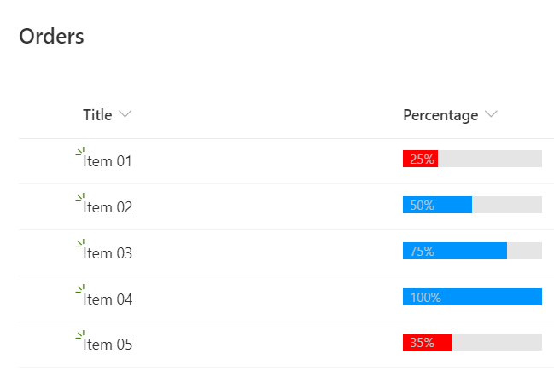

**Deploy the filed customizer**

* gulp clean
* gulp build
* gulp bundle –ship
* gulp package-solution –ship

**Drag and drop the app to appcatalog**

1. You now need to deploy the package that was generated to the app catalog. To do this, go to your tenant's app catalog and open the **Apps for SharePoint** library.
2. Upload the file **./sharepoint/solution/field-extension.sppkg** to the app catalog.
3. Select the **Deploy** button.

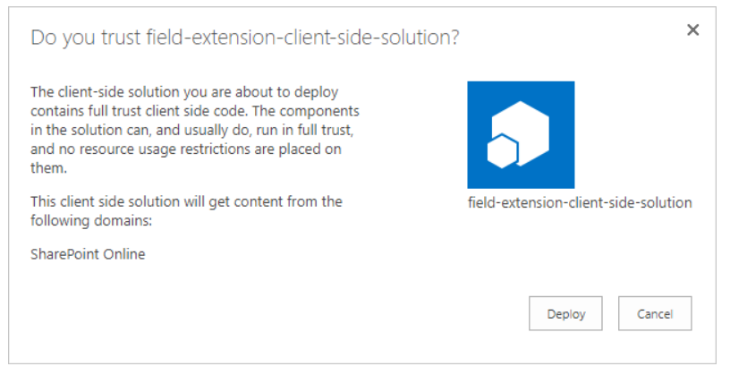

1. Go to the site where you want to test SharePoint asset provisioning. This could be any site collection in the tenant where you deployed this solution package.
2. Select the gears icon on the top navigation bar on the right, and then select **Add an app**.
3. In the **Search** box, enter **field**, and then select ENTER to filter your apps.

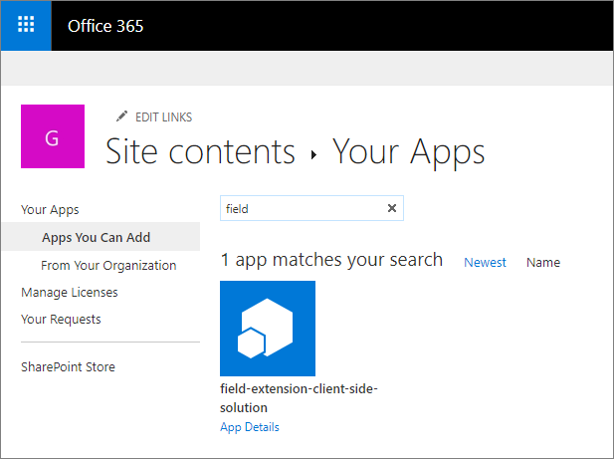

1. Select the **field-extension-client-side-solution** app to install the solution on the site. After the installation is complete, refresh the page.
2. Go to Orders list 🡪 list settings
3. Select **Columns** > **Add from existing site columns**.
4. Select the **SPFx Columns** > **Percentage** field that was provisioned from the solution package, and then select **OK**.

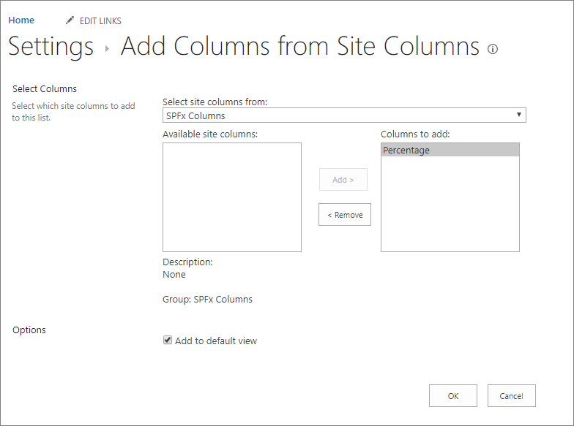

Now you can see the site column applied the field customizer

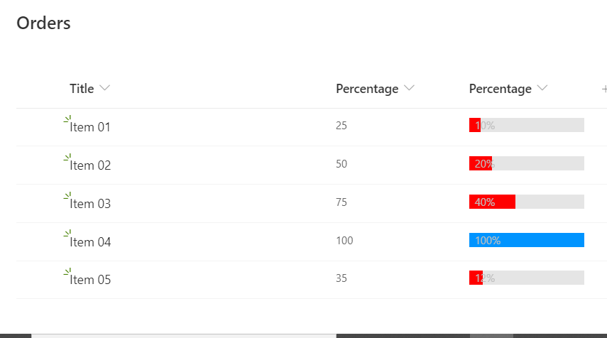

Refer ./sharepoint/assets/elements.xml 🡪 site column created from our code

<?xml version="1.0" encoding="utf-8"?>

<Elements xmlns="http://schemas.microsoft.com/sharepoint/">

    <Field ID="{834077f3-381f-4345-8077-32a847beb87b}"

            Name="SPFxPercentage"

            DisplayName="Percentage"

            Type="Number"

            Min="0"

            Required="FALSE"

            Group="SPFx Columns"

            ClientSideComponentId="1052338b-ed07-4316-9e1e-b28c81a83945">

    </Field>

</Elements>

Add field as per your requirement.